Python Interview Questions and Answers
Python is the most used language in top companies such as Intel, IBM, NASA, Pixar, Netflix, Facebook, JP Morgan Chase, Spotify and many more because of its simplicity and powerful libraries.

- 1. Is Python a compiled language or an interpreted language?
-- Python is considered an interpreted language in practice.
Please remember one thing, whether a language is compiled or interpreted or both is not defined in the language standard. In other words, it is not a properly of a programming language. Different Python distributions (or implementations) choose to do different things (compile or interpret or both). However the most common implementations like CPython do both compile and interpret, but in different stages of its execution process.
- Interpretation: After Python code is compiled into bytecode, it is executed by the Python Virtual Machine (PVM), which is an interpreter. The PVM reads the bytecode and executes it line-by-line at runtime, which is why Python is considered an interpreted language in practice.
- Compilation: When you write Python code and run it, the source code (.py files) is first compiled into an intermediate form called bytecode (.pyc files). This bytecode is a lower-level representation of your code, but it is still not directly machine code. It’s something that the Python Virtual Machine (PVM) can understand and execute.
Some implementations, like PyPy, use Just-In-Time (JIT) compilation, where Python code is compiled into machine code at runtime for faster execution, blurring the lines between interpretation and compilation.
=========================================================================================================================================================================================
2. How can you concatenate two lists in Python?
We can concatenate two lists in Python using the “+”operator or the extend() method.
1. Using the + operator:
This creates a new list by joining two lists together.
a = [1, 2, 3]
b = [4, 5, 6]
res = a + b
print(res)
Output
[1, 2, 3, 4, 5, 6]

2. Using the extend() method:
This adds all the elements of the second list to the first list in-place.
a = [1, 2, 3]
b = [4, 5, 6]
a.extend(b)
print(a)
Output
[1, 2, 3, 4, 5, 6]
=========================================================================================================================================================================================

3. Difference between for loop and while loop in Python
- For loop: Used when we know how many times to repeat, often with lists, tuples, sets, or dictionaries.
- While loop: Used when we only have an end condition and don’t know exactly how many times it will repeat.
for i in range(5):
print(i)
​
c = 0
while c < 5:
print(c)
c += 1
Output
0
1
2
3
4
0
1
2
3
4
=========================================================================================================================================================================================

4. How do you floor a number in Python?
To floor a number in Python, you can use the math.floor() function, which returns the largest integer less than or equal to the given number.
- floor()method in Python returns the floor of x i.e., the largest integer not greater than x.
- Also, The method ceil(x) in Python returns a ceiling value of x i.e., the smallest integer greater than or equal to x.
import math
​
n = 3.7
F_num = math.floor(n)
​
print(F_num)
Output
3
=========================================================================================================================================================================================

5. What is the difference between / and // in Python?
/ represents precise division (result is a floating point number)
ex—
print(5/2)
Output: 2.5

// represents floor division (result is an integer). For Example:
print(5//2)
output :2

=========================================================================================================================================================================================

6. Is Indentation Required in Python?
Yes, indentation is required in Python.
A Python interpreter can be informed that a group of statements belongs to a specific block of code by using Python indentation.
Indentations make the code easy to read for developers in all programming languages but in Python, it is very important to indent the code in a specific order.
=========================================================================================================================================================================================

7. Can we Pass a function as an argument in Python?
Yes, Several arguments can be passed to a function, including objects, variables and functions. (of the same or distinct data types).
Functions can be passed as parameters to other functions because they are objects.
Higher-order functions are functions that can take other functions as arguments.

def add(x, y):
return x + y
​
def apply_func(func, a, b):
return func(a, b)
​
print(apply_func(add, 3, 5))
Output
8
The add function is passed as an argument to apply_func, which applies it to 3 and 5.
=========================================================================================================================================================================================

8. What is a dynamically typed language?
- In a dynamically typed language, the data type of a variable is determined at runtime, not at compile time.
- No need to declare data types manually; Python automatically detects it based on the assigned value.
- Examples of dynamically typed languages: Python, JavaScript.
- Examples of statically typed languages: C, C++, Java.
- Dynamically typed languages are easier and faster to code.
- Statically typed languages are usually faster to execute due to type checking at compile time.
Example:
x = 10 # x is an integer
x = "Hello" # Now x is a string
Here, the type of x changes at runtime based on the assigned value hence it shows dynamic nature of Python.
=========================================================================================================================================================================================

****very important Question*****
=========================================================================================================================================================================================

12. What is List Comprehension? Give an Example.
List comprehension is a way to create lists using a concise syntax.
It allows us to generate a new list by applying an expression to each item in an existing iterable (such as a list or range).
This helps us to write cleaner, more readable code compared to traditional looping techniques.
For example, if we have a list of integers and want to create a new list containing the square of each element, we can easily achieve this using list comprehension.
a = [2,3,4,5]
res = [val ** 2 for val in a]
print(res)
Output [4, 9, 16, 25]
=========================================================================================================================================================================================

15. What is the difference between a Set and Dictionary?
- A Python Set is an unordered collection data type that is iterable, mutable and has no duplicate elements.
Python’s set class represents the mathematical notion of a set.
- Syntax: Defined using curly braces {} or the set() function.
my_set = {1, 2, 3}

- Dictionary in Python is an ordered (since Py 3.7) [unordered (Py 3.6 & prior)] collection of data values, used to store data values like a map, which, unlike other Data Types that hold only a single value as an element,
- Dictionary holds key:value pair. Key-value is provided in the dictionary to make it more optimized.
- Syntax: Defined using curly braces {} with key-value pairs.
my_dict = {"a": 1, "b": 2, "c": 3}
=========================================================================================================================================================================================

17. What is the difference between a Mutable datatype and an Immutable data type?
- Mutable data types can be edited i.e., they can change at runtime. Eg – List, Dictionary, etc.
- Immutable data types can not be edited i.e., they can not change at runtime. Eg – String, Tuple, etc.
=========================================================================================================================================================================================

18. What is a Variable Scope in Python?
The location where we can find a variable and also access it if required is called the scope of a variable.
- Python Local variable: Local variables are initialized within a function and are unique to that function. A local variable cannot be accessed outside of the function.
- Python Global variables: Global variables are defined and declared outside any function and are not specified to any function.
- Module-level scope: It refers to the global objects of the current module accessible in the program.
- Outermost scope: It refers to any built-in names that the program can call. The name referenced is located last among the objects in this scope.
- =========================================================================================================================================================================================

19. How is a dictionary different from a list?
A list is an ordered collection of items accessed by their index, while a dictionary is an unordered collection of key-value pairs accessed using unique keys. Lists are ideal for sequential data, whereas dictionaries are better for associative data. For example, a list can store [10, 20, 30], whereas a dictionary can store {"a": 10, "b": 20, "c": 30}.
=========================================================================================================================================================================================

21. How is Exceptional handling done in Python?
There are 3 main keywords i.e. try, except and finally which are used to catch exceptions:
- try: A block of code that is monitored for errors.
- except: Executes when an error occurs in the try block.
- finally: Executes after the try and except blocks, regardless of whether an error occurred. It’s used for cleanup tasks.
Example: Trying to divide a number by zero will cause an exception.
n = 10
try:
res = n / 0 # This will raise a ZeroDivisionError

except ZeroDivisionError:
print("Can't be divided by zero!")
Output
Can't be divided by zero!
Explanation: In this example, dividing number by 0 raises a ZeroDivisionError. The try block contains the code that might cause an exception and the except block handles the exception, printing an error message instead of stopping the program.
=========================================================================================================================================================================================
Intermediate Python Interview Questions
24. What is the difference between xrange and range functions?
range() and xrange() are two functions that could be used to iterate a certain number of times in for loops in Python.
- In Python 3, there is no xrange, but the range function behaves like xrange.
- In Python 2
  - range() – This returns a range object, which is an immutable sequence type that generates the numbers on demand.
  - xrange() – This function returns the generator object that can be used to display numbers only by looping. The only particular range is displayed on demand and hence called lazy evaluation.
=========================================================================================================================================================================================

25. What is Dictionary Comprehension? Give an Example
Dictionary Comprehension is a syntax construction to ease the creation of a dictionary based on the existing iterable.
keys = ['a','b','c','d','e']
values = [1,2,3,4,5]
​
# this line shows dict comprehension here
d = { k:v for (k,v) in zip(keys, values)}
# We can use below too
# d = dict(zip(keys, values))
print (d)
Output
{'a': 1, 'b': 2, 'c': 3, 'd': 4, 'e': 5}
=========================================================================================================================================================================================

26. Is Tuple Comprehension possible in Python? If yes, how and if not why?
Tuple comprehensions are not directly supported, Python's existing features like generator expressions and the tuple() function provide flexible alternatives for creating tuples from iterable data.
(i for i in (1, 2, 3))
Tuple comprehension is not possible in Python because it will end up in a generator, not a tuple comprehension.
=========================================================================================================================================================================================

28. What is the difference between a shallow copy and a deep copy?
Below is the tabular Difference between the Shallow Copy and Deep Copy:
Shallow Copy | Deep Copy
Shallow Copy stores the references of objects to the original memory address. | Deep copy stores copies of the object’s value.
Shallow Copy reflects changes made to the new/copied object in the original object. | Deep copy doesn’t reflect changes made to the new/copied object in the original object.
Shallow Copy stores the copy of the original object and points the references to the objects. | Deep copy stores the copy of the original object and recursively copies the objects as well.
A shallow copy is faster. | Deep copy is comparatively slower.

=========================================================================================================================================================================================

29. Which sorting technique is used by sort() and sorted() functions of python?
Python uses the Tim Sort algorithm for sorting. It’s a stable sorting whose worst case is O(N log N). It’s a hybrid sorting algorithm, derived from merge sort and insertion sort, designed to perform well on many kinds of real-world data.
=========================================================================================================================================================================================

31. How do you debug a Python program?
1. Using pdb (Python Debugger):
pdb is a built-in module that allows you to set breakpoints and step through the code line by line. You can start the debugger by adding import pdb; pdb.set_trace() in your code where you want to begin debugging.
import pdb
x = 5
pdb.set_trace() # Debugger starts here
print(x)
Output
> /home/repl/02c07243-5df9-4fb0-a2cd-54fe6d597c80/main.py(4)<module>()
-> print(x)
(Pdb)
2. Using logging Module:
For more advanced debugging, the logging module provides a flexible way to log messages with different severity levels (INFO, DEBUG, WARNING, ERROR, CRITICAL).
import logging
logging.basicConfig(level=logging.DEBUG)
logging.debug("This is a debug message")
Output
DEBUG:root:This is a debug message

=========================================================================================================================================================================================

32. What are Iterators in Python?
In Python, iterators are used to iterate a group of elements, containers like a list.
Iterators are collections of items and they can be a list, tuples, or a dictionary.
Python iterator implements __itr__ and the next() method to iterate the stored elements. We generally use loops to iterate over the collections (list, tuple) in Python.
=========================================================================================================================================================================================

34. Does Python supports multiple Inheritance?
When a class is derived from more than one base class it is called multiple Inheritance. The derived class inherits all the features of the base case.
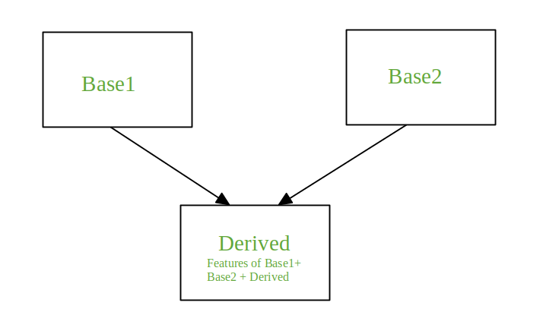Multiple Inheritance
Python does support multiple inheritances, unlike Java.

=========================================================================================================================================================================================

35. What is Polymorphism in Python?
simple language
Polymorphism means one thing can behave in different ways.
Same method name, but it works differently depending on the object.”
Polymorphism means the ability to take multiple forms.
Polymorphism is about overriding, not overloading

Polymorphism allows different classes to be treated as if they are instances of the same class through a common interface. This means that a method in a parent class can be overridden by a method with the same name in a child class, but the child class can provide its own specific implementation. This allows the same method to operate differently depending on the object that invokes it. Polymorphism is about overriding, not overloading; it enables methods to operate on objects of different classes, which can have their own attributes and methods, providing flexibility and reusability in the code.
=========================================================================================================================================================================================

36. Define encapsulation in Python?
Encapsulation is the process of hiding the internal state of an object and requiring all interactions to be performed through an object’s methods. This approach:
- Provides better control over data.
- Prevents accidental modification of data.
- Promotes modular programming.
Python achieves encapsulation through public, protected and private attributes.
example : Bank Account
=========================================================================================================================================================================================

37. How do you do data abstraction in Python?
Data Abstraction is providing only the required details and hides the implementation from the world. The focus is on exposing only the essential features and hiding the complex implementation behind an interface. It can be achieved in Python by using interfaces and abstract classes.
example: ATM Machine school bag
=========================================================================================================================================================================================

39. How to delete a file using Python?
We can delete a file using Python by following approaches:
- Python Delete File using os. remove
- Delete file in Python using the send2trash module
- Python Delete File using os.rmdir
=========================================================================================================================================================================================

41. What is a namespace in Python?
A namespace in Python refers to a container where names (variables, functions, objects) are mapped to objects. In simple terms, a namespace is a space where names are defined and stored and it helps avoid naming conflicts by ensuring that names are unique within a given scope.
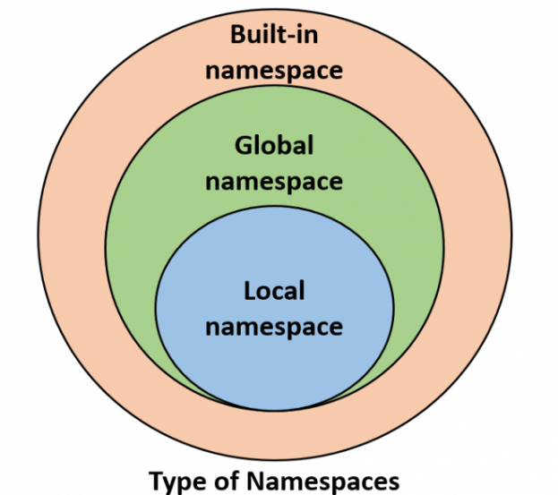
Types of Namespaces:
- Built-in Namespace: Contains all the built-in functions and exceptions, like print(), int(), etc. These are available in every Python program.
- Global Namespace: Contains names from all the objects, functions and variables in the program at the top level.
Local Namespace: Refers to names inside a function or method. Each function call creates a new local namespace.
=========================================================================================================================================================================================

Python Interview
Advanced Python Interview Questions & Answers

42. What is PIP?
PIP is an acronym for Python Installer Package which provides a seamless interface to install various Python modules. It is a command-line tool that can search for packages over the internet and install them without any user interaction.
43. What is a zip function?
Python zip() function returns a zip object, which maps a similar index of multiple containers. It takes an iterable, converts it into an iterator and aggregates the elements based on iterables passed. It returns an iterator of tuples.
Syntax:
zip(*iterables)
=========================================================================================================================================================================================

45. What is the difference between @classmethod, @staticmethod and instance methods in Python?
1. Instance Method operates on an instance of the class and has access to instance attributes and takes self as the first parameter. Example:
def method(self):
2. Class Method directly operates on the class itself and not on instance, it takes cls as the first parameter and defined with @classmethod.
Example: @classmethod def method(cls):
3. Static Method does not operate on an instance or the class and takes no self or cls as an argument and is defined with @staticmethod.
Example: @staticmethod def method(): align it and dont bolod anything and not bullet points
=========================================================================================================================================================================================

46. What is __init__() in Python and how does self play a role in it?
- __init__() is Python's equivalent of constructors in OOP, called automatically when a new object is created. It initializes the object's attributes with values but doesn’t handle memory allocation.
- Memory allocation is handled by the __new__() method, which is called before __init__().
- The self parameter in __init__() refers to the instance of the class, allowing access to its attributes and methods.
- self must be the first parameter in all instance methods, including __init__()
class MyClass:
def __init__(self, value):
self.value = value # Initialize object attribute
​
def display(self):
print(f"Value: {self.value}")
​
obj = MyClass(10)
obj.display()
Output
Value: 10
=========================================================================================================================================================================================

47. Write a code to display the current time?
import time
​
currenttime= time.localtime(time.time())
print ("Current time is", currenttime)
Output
Current time is time.struct_time(tm_year=2025, tm_mon=6, tm_mday=10, tm_hour=11, tm_min=56, tm_sec=57, tm_wday=1, tm_yday=161, tm_isdst=0)

=========================================================================================================================================================================================

50. Python Global Interpreter Lock (GIL)?
Python Global Interpreter Lock (GIL) is a type of process lock that is used by Python whenever it deals with processes. Generally, Python only uses only one thread to execute the set of written statements. The performance of the single-threaded process and the multi-threaded process will be the same in Python and this is because of GIL in Python. We can not achieve multithreading in Python because we have a global interpreter lock that restricts the threads and works as a single thread.
=========================================================================================================================================================================================

51. What are Function Annotations in Python?
- Function Annotation is a feature that allows you to add metadata to function parameters and return values. This way you can specify the input type of the function parameters and the return type of the value the function returns.
- Function annotations are arbitrary Python expressions that are associated with various parts of functions. These expressions are evaluated at compile time and have no life in Python’s runtime environment. Python does not attach any meaning to these annotations. They take life when interpreted by third-party libraries, for example, mypy.
- =========================================================================================================================================================================================

52. What are Exception Groups in Python?
The latest feature of Python 3.11, Exception Groups. The ExceptionGroup can be handled using a new except* syntax. The * symbol indicates that multiple exceptions can be handled by each except* clause.
ExceptionGroup is a collection/group of different kinds of Exception. Without creating Multiple Exceptions we can group together different Exceptions which we can later fetch one by one whenever necessary, the order in which the Exceptions are stored in the Exception Group doesn’t matter while calling them.
try:
raise ExceptionGroup('Example ExceptionGroup', (
TypeError('Example TypeError'),
ValueError('Example ValueError'),
KeyError('Example KeyError'),
AttributeError('Example AttributeError')
))
except* TypeError:
...
except* ValueError as e:
...
except* (KeyError, AttributeError) as e:
...
=========================================================================================================================================================================================

53. What is Python Switch Statement?
From version 3.10 upward, Python has implemented a switch case feature called “structural pattern matching”. You can implement this feature with the match and case keywords. Note that the underscore symbol is what you use to define a default case for the switch statement in Python.
Note: Before Python 3.10 Python doesn't support match Statements.
match term:
case pattern-1:
action-1
case pattern-2:
action-2
case pattern-3:
action-3
case _:
action-default

=========================================================================================================================================================================================

54. What is Walrus Operator?
- Walrus Operator allows you to assign a value to a variable within an expression. This can be useful when you need to use a value multiple times in a loop, but don't want to repeat the calculation.
- Walrus Operator is represented by the `:=` syntax and can be used in a variety of contexts including while loops and if statements.
Note: Python versions before 3.8 doesn't support Walrus Operator.
numbers = [1, 2, 3, 4, 5]
​
while (n := len(numbers)) > 0:
print(numbers.pop())
Output
5
4
3
2
1

